Date: Oct 31, 2012
To: William Flynn, GISP
City of New Braunfels
wflynn@nbtexas.org
(830) 221-4339
From: The G.A.M.E.S.
CC: Dr. Yongmei Lu

The City of New Braunfels Parks and Recreations Asset Management Project

Introduction:
The G.A.M.E.S. is presenting the following progress report for the City of New Braunfels Parks and Recreations Asset Management Project that began on September 5th, 2012. In this report will be a brief review of the project description and detailed information on the work that The G.A.M.E.S. have completed, are still working on, or will finish, as well as changes to the timeline and any problems encountered along the way.
Project Description:
The City of New Braunfels approached Texas State University’s GIS department or more specifically Dr. Lu, with the opportunity to work with them to create an asset GIS schema for their Parks and Recreations Department with the ultimate goal of it being implemented into their existing Accela asset management system. As The G.A.M.E.S. working under Dr. Lu, it is our purpose to work with the City of New Braunfels in designing the necessary asset GIS geodatabase that will be able to integrate in with the City’s Accela asset management system and make sure that it will be able to “serve as the structure for inventorying this asset information” (City of New Braunfels). To accomplish this our team has done, is in the process of doing, or will do: formal needs assessments’ with Park and Recreation staff, design a GIS schema or geodatabase around park assets, conduct field work with GPS units as well as moderate digitizing to collect any data needed, and finally help the CoNB GIS Analyst/Accela Manager William Flynn synch the GIS geodatabase with Accela. It is our teams expectations that with such a merging of GIS and Accela’s asset management system that the City of New Braunfels will be able to better manage their parks assets, infrastructure, and predict maintenance costs better, as well as generate preventive maintenance work orders months in advance that automatically get sent out to the correct departments and their workers.

The scope of the project has been narrowed down thanks to help from Kelly Eby and Kelsey Heiden of the Parks and Recreations Department that were interviewed as part of the Phase I: Needs Assessment on October 10, 2012. They gave us a list of the Parks and other areas under their care that they wanted us to target for this project. These areas can be seen in Appendixes C-D in the Maps and some of the information about these areas can be found in the Attribute Table examples in Appendixes A-B. Other assets to be considered for the project but are not listed in the Appendix are picnic areas, drinking fountains, flower beds, trees, pavilions, water features, and historical markers. As of now things seem to be going as scheduled and The G.A.M.E.S. should be able to meet the deadline for this project by December 10, 2012.
Needs Assessment/CURRENT:
- We still have questions regarding some of the asset locations and how they wish to represent some of the data that we are unsure of. For example the walnut widening is still under construction so we need to find out exactly which assets and attributes about the walnut widening needs to collected and recorded.
Tasks:
Phase I: Needs Assessment
Completed
- The team attended several meetings with William Flynn in which he introduced the group to the projects details, created access accounts to necessary databases, and established meeting dates with the New Braunfels Parks Department representatives. Several critical issues were revealed and discussed that could prevent the asset management system from working correctly. Furthermore, the team was also given access to the city ftp site and Acella in its support environment so that the database contents could be explored. Appointments with parks department representatives were also confirmed with Mr. Flynn, as well as what representatives were attending the meeting.

- GAMES joined a meeting hosted by Mr. Flynn and attended by Kelsey Heiden (New Braunfels Parks Departments’ Administrative Secretary) along with Kelly Eby (New Braunfels Parks Department Urban Forester). The meeting included discussions of numerous assets and maintenance tasks that were relevant to the department’s day to day operations. Ideas of what things the department could best use in their asset management system were discussed, researched and confirmed throughout the meeting. A common concept was established throughout the group on what needed to be implemented into the project. Available data that could be utilized was given to the team by the parks staff to be employed throughout the project.

In Progress
- Future meetings with county employees and additional parks personnel are required for the project. Further information supplied by representatives from both departments will be essential to expanding and fine tuning the asset management system.

Phase II: Evaluating Existing Data
Completed
- The team researched and classified data that could be utilized in the integration of GIS and Accela. Necessary data that the New Braunfels Parks Department was unable to provide was located and obtained from other sources by GAMES. These sources mainly included the county database and data extracted from online resources such as the GIS section of the New Braunfels website.

- For successful integration between the software it is necessary for the naming structure of the data to relate. To account for this the team cross referenced feature labels and metadata between Accela and ArcCatalog to accommodate the matching requirements for the necessary transitions they may include. Essential data that did not contain adequate records or relevant information had to be manipulated in order to achieve compatibility in the incorporated system. This manipulation involved going through the records of the spatial data, and modifying it in a fashion in which it was useful and appropriately structured. The modifications included editing tables by adding features or by deletion of unnecessary data and digitizing polygons where needed.

- Several processes were necessary to create a geodatabase that can demonstrate compatibility with an asset management system. Among the many fields of metadata analyzed, asset identification and park name are the most essential for future operators of the system. Based on the input received from the client, it was determined that a conventional field needed to be created in order for the integration to occur successfully. The team assigned a numeric system labeled as AssetID and applied it to the data that would be used between the two programs to produce the asset management system. While a collective asset identification method is essential, operators of the system must be able to easily identify required data. To account for this, conventional names that are frequently used by the government departments and local citizens were implemented as the parks names to help prevent misperception in identification.

Phase III: Database Modeling/Construction
Ongoing
- Previously manipulated data which is rendered and tested to be compatible; can then be previewed in the asset management software. Analysis of this data from the Accela support environment furnishes the team with additional ideas on what can be done to ensure optimum quality in the asset management system. Attributes, fields, and domains are among the items that could be necessary to edit within the system.
- The appropriate data structure that is determined from research and testing of the system can then be modeled and implemented throughout all the necessary data. Because of the modeled data structure of these files, they will then be able to be synced between the software without causing error as well as provide the additional edits that were applied.
- Using this model as a blueprint, the GAMES will then be able to modify or construct any additional geodatabases needed for the project. Data structured by using the model as a blue print can then be utilized with an online map service that not only allows for the operation of Acella; but for the service to be utilized remotely.

Phase IV: Data Collection
Upcoming
- Relevant data dictionaries could possibly need to be constructed or edited to ensure seamless data collection for future operators. Appropriate input fields that are relevant and helpful to the surveyor must be included in the data dictionary which will be uploaded into Garmin Geo XH. The fields must include drop down tabs containing valuable feature information that will further provide efficient selection of the available datasets. Blank fields must also be provided so that the data collector can summarize their findings and add any additional information they feel necessary.
- GPS positions will then be recorded on features that are predetermined to fulfill as many of the possible input classifications that can conceivably be needed in successful data collection. The positions will vary not only in type, but also in location to test the system’s ability to operate with different park data. Trees, water features, pavilions, picnic areas, flower beds, historical markers, and drinking fountains are among many assets that will be surveyed to test the model.
- The collected data will then be corrected and uploaded into the geodatabase so it can be integrated into the Asset Management system for further testing. The software Pathfinder office will be instrumented in performing the necessary corrections for each GPS recording.
- Multiple tests will be performed, to search for any errors that could be encountered by future operators. Every aspect of the geodatabase will be reviewed and repeatedly tested. Any errors that occur would then be properly corrected and the process repeated systematically to reassure the error is amended.
- The completed project would then be prepared to be successfully implemented and utilized by the New Braunfels Parks Department employees. Creation of work orders, inventory catalogues, as well asset management would be available to make use of. Ideally, seamless work orders throughout the system could not only be created for employees on an as need basis, but can be automatically created and self-generate preventative maintenance work orders successfully.

Asset Management Timetable
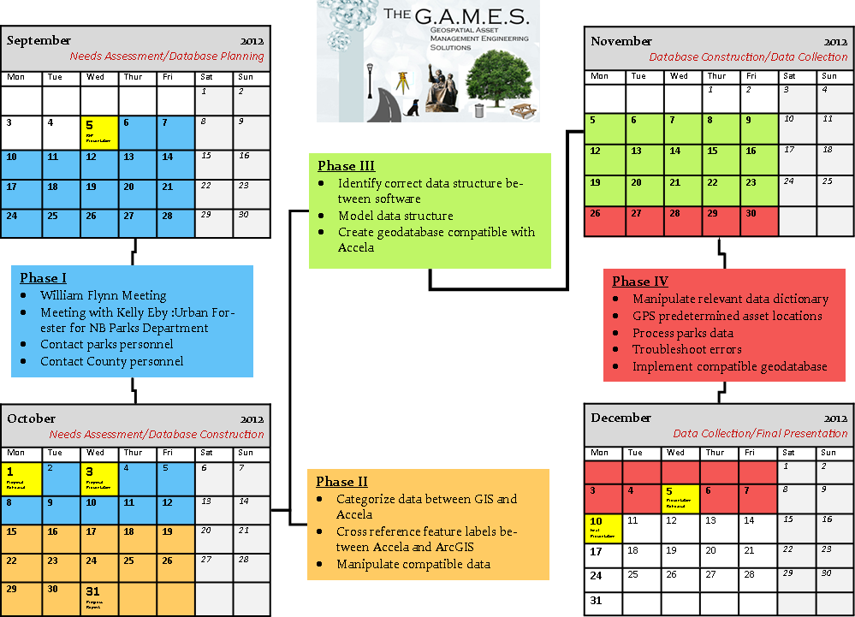

Timetable Edits:
- Last time we met Mr.Flynn in class for our Proposal. The team discussed about our Asset Management Progress Report Timeline. Since our last visit with Mr. Flynn, we have changed our timeline slightly. This Asset Management report will discuss why we have changed our timeline and any complications that will result.

- The first change the Games have added to the timeline deals with Phase I of our timeline. Currently we have finished everything in Phase I, except additional meetings with the Parks and Recreation Staff with Kelly Eby and Kelsey Heiden. The reason we need to have additional meetings with the Parks and Rec. Staff is because we still have questions regarding some of the assets locations and how they wish to represent some of the data. For example, we have a few assets missing addresses due to hole punches in the Asset list supplied by the Parks and Recreation Staff as well as representing assets under construction. Phase II: evaluating existing database. As of now, we need more time evaluating data given to us by the Parks Deparment and Mr.Flynn. We are confident we can finish evaluating data with the Parks and Recreation Staff and Mr.Flynn.

- Even with the extension of phase II heading into this week and left over work from Phase I. We are confident we are on track to finish our City Of New Braunfels Asset Management Project December 10, 2012.

Appendix A (map)
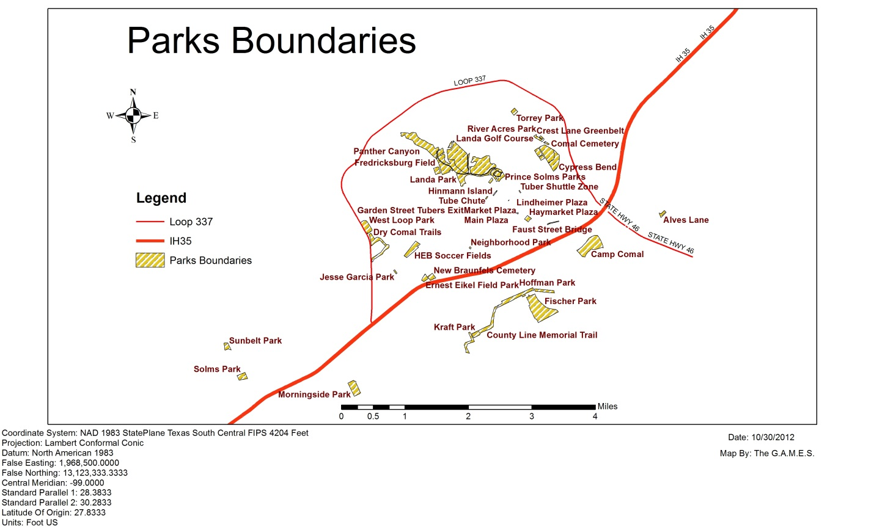Appendix B (map) (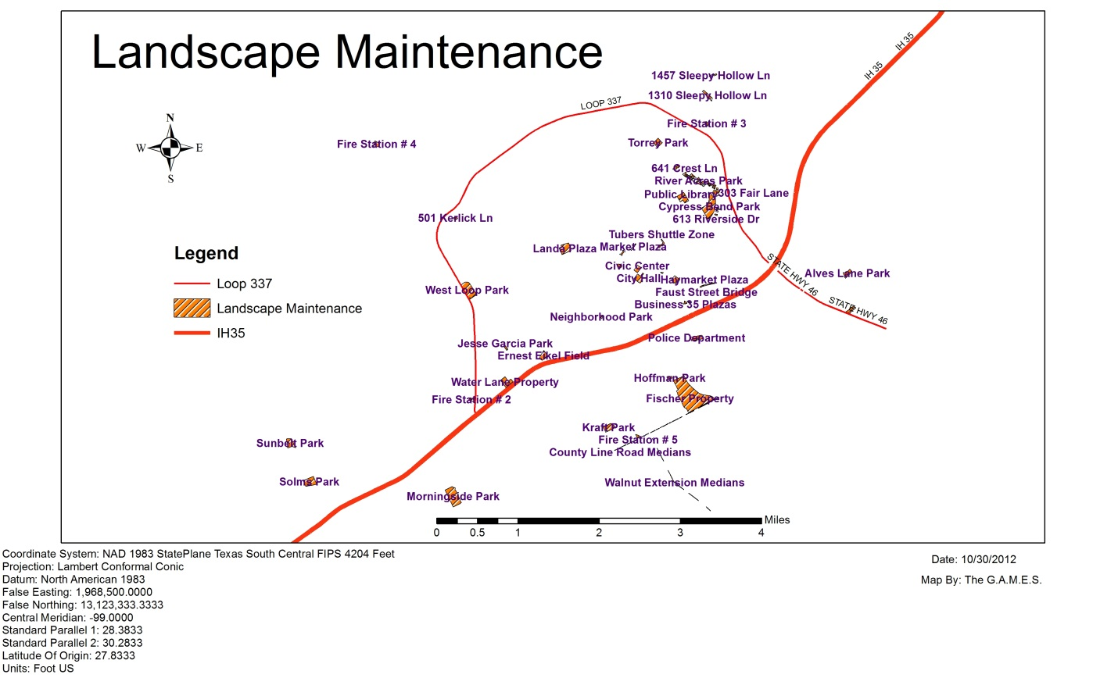

Conclusion:

The data will be based off a GIS geodatabase that will synchronize with Accela software. The project will help design and create an effective asset management system for the Parks Department of the city of New Braunfels. The AMS will be used by the city employees to schedule work orders in order to maintain the related assets to the park. The effective asset management system will be presented to city council and possibly used in all other city departments.

References:

City of New Braunfels, Request For Proposal, City of New Braunfels, Texas, August 2012.
Dan Saltzman. Portlandonline.com. Total Asset Management, July 2006. Web. September 20, 2012. http://www.portlandonline.com/parks/index.cfm?a=151131&c=38306
Image 1: http://www.esri.com/news/arcnews/spring12articles/spring12gifs/p16p1-lg.jpg
Image 2 : http://www.newbraunfelsfunthingsinlife.com/
Joel Hillhouse. ESRI.com. ArcNews, Spring 2012. Web. September 29, 2012. http://www.esri.com/news/arcnews/spring12articles/city-of-las-vegas-implements-parkpad-for-mobile-asset-management.html
Lemer, A. (1998). Progress Toward Intergrated Infrastructure Asset Management Systems: GIS and Beyond. APWA International Public Works Congress, 1-18.

